 | SR UNIVERSITY  Campus Warangal
 | Program: II - B. Tech (CS& AI) Batch: 57(DATA SCIENCE)
 | Name: MOHAMMAD BILAL Reg. No:
 | Department: Computer Science and AI Semester: I
 | AI Assisted Coding-Assignment Date: 18/09/2026

Q1. Class with Conditional Logic – Employee Salary

1.QUESTION
Create a Python class Employee that stores the employee's name and basic salary. The class should calculate the employee's bonus using conditional logic: 10% of the salary if the salary is ₹50,000 or above, otherwise 5%. Display the employee's name, basic salary, bonus, and total salary. Create at least two employee objects and test both conditions.

2.PROMPT
Create a Python program using an Employee class with name and basic_salary. Calculate a 10% bonus if salary ≥ ₹50,000, otherwise 5%. Calculate and display the total salary. Create two employee objects and test both conditions.

3.CODE
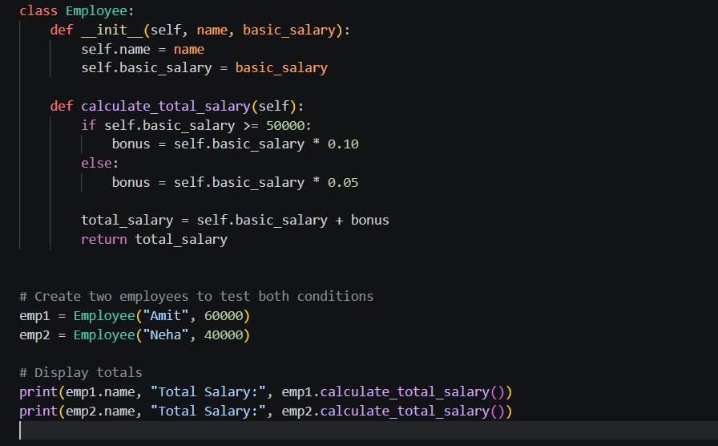

4.OUTPUT :
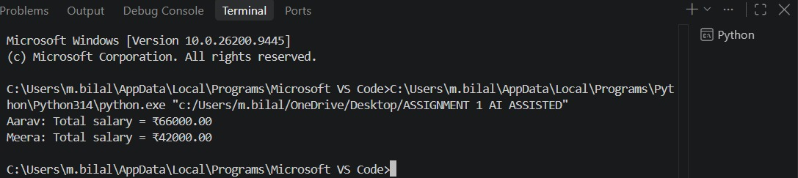

5.OBSERVATION :
The program successfully creates the Employee class and calculates the bonus using an if-else condition. Amit, with a salary of ₹60,000, receives a 10% bonus, resulting in a total salary of ₹66,000, while Neha, with a salary of ₹40,000, receives a 5% bonus, resulting in a total salary of ₹42,000. The output confirms that both conditions work correctly and the total salary is calculated successfully.

Q2. Loop and Conditional Logic – Student Marks
1.QUESTION
Write a Python program that accepts a list of student marks and uses a loop and conditional statements to classify each student as Distinction for marks ≥ 75, Pass for marks between 40 and 74, and Fail for marks below 40. The program should ignore invalid marks outside the range of 0–100 and display the total number of students in each category.
2.PROMPT :
Create a Python program that takes a list of student marks and uses a for loop with if-elif-else conditions to classify the marks as Distinction (≥75), Pass (≥40 and <75), or Fail (<40). Ignore invalid marks outside 0–100 and count the number of students in each category. Test the program with a suitable list of marks.

3.CODE :
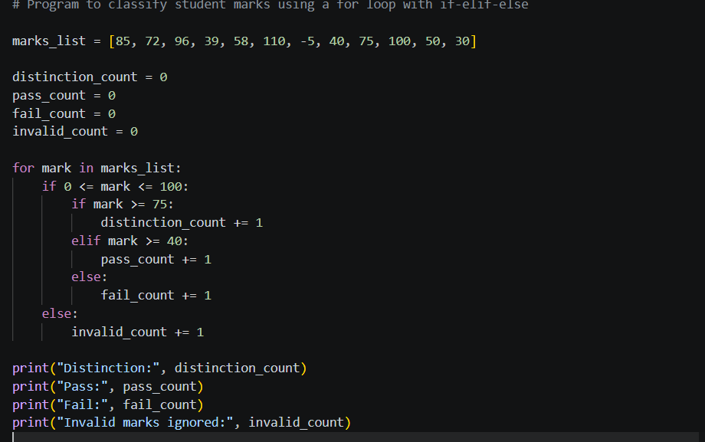

4.OUTPUT :

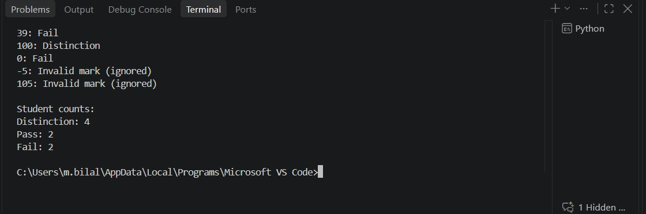

5.OBSERVATION :
The program successfully processes the student marks using a for loop and conditional statements. It correctly classifies valid marks into Distinction, Pass, and Fail categories according to the given conditions. Marks outside the range of 0–100 are ignored, and the program successfully counts and displays the number of students in each category.

Q3. Class + Loop – Product Inventory

1.QUESTION
Create a Python program using a Product class to manage store inventory. The class should store the product name, price, and quantity, calculate the total value of each product using price × quantity, and use a loop to calculate the total inventory value. The program should also display products with a quantity less than 5 as "Low Stock" and test the program with at least three products.

2.PROMPT :
Create a Python program using a Product class with product name, price, and quantity. Add a total_value() method to calculate price × quantity. Create a list of at least three Product objects and use a for loop to calculate the total inventory value. Display products whose quantity is less than 5 as "Low Stock".
3.CODE :
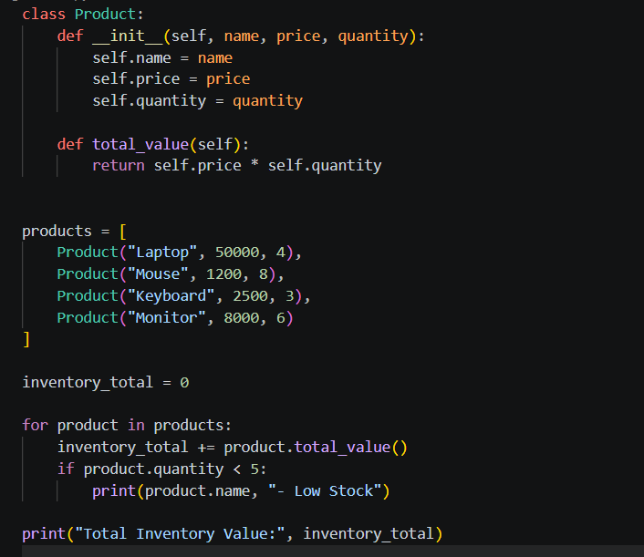

4.OUTPUT :
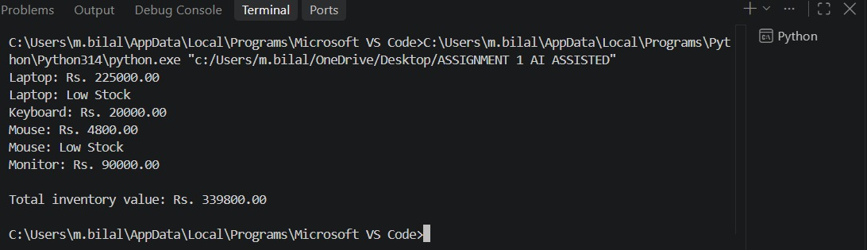

5.OBSERVATION :
The program successfully creates Product objects and stores their name, price, and quantity. The total_value() method calculates the value of each product by multiplying its price and quantity, while the loop calculates the total inventory value. The program also correctly identifies and displays products with a quantity less than 5 as "Low Stock".

Q4. Class + Loop + Nested Conditions – Electricity Bill
1.QUESTION
Create a Python program using an ElectricityBill class to calculate electricity bills based on the units consumed. The class should store the consumer name and units consumed and calculate the bill using ₹2 per unit for the first 100 units, ₹3 per unit for units from 101–200, and ₹5 per unit for units above 200. Create at least three objects with different unit values, including an edge value such as 100 or 200, and display the consumer name, units consumed, and total bill.
2.PROMPT :
Create a Python program using an ElectricityBill class with consumer name and units consumed. Use conditional statements to calculate the bill at ₹2 per unit for the first 100 units, ₹3 per unit for 101–200 units, and ₹5 per unit for units above 200. Create at least three objects with different unit values, including 100 or 200, and display the consumer name, units, and total bill.
3.CODE :
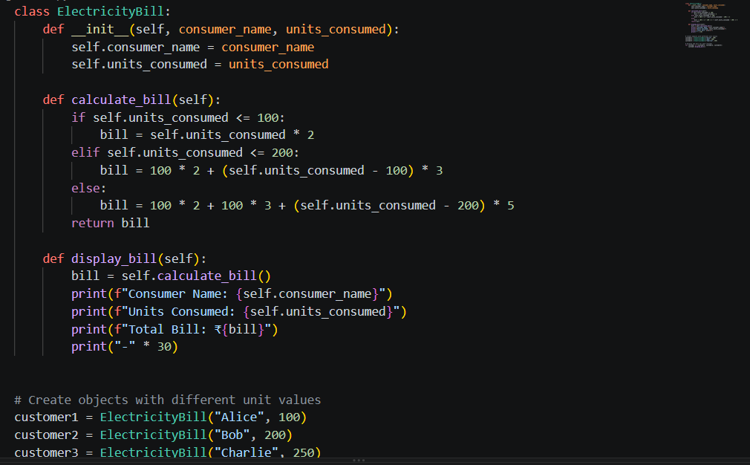
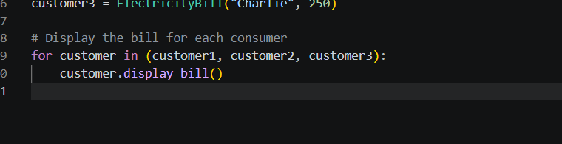

4.OUTPUT :
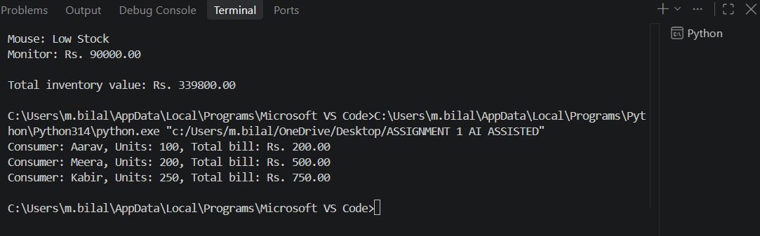

5.OBSERVATION :
The program successfully creates electricity bill objects and calculates the bill according to the units consumed. Conditional statements are used to apply the correct rate for each unit range. The program correctly handles different unit values, including the edge values of 100 and 200, and displays the consumer name, units consumed, and calculated total bill.

